

In 2017, the VA Office of Research & Development changed their Requests for Applications to promote inclusion of women in VA prosthetics research to expand testing, development, and treatment capabilities to meet women Veterans’ prosthetic needs. This brief provides an overview of recently funded research.
VA Women Veterans’ Prosthetics Research

VA Rehabilitation Research and Development (RR&D) Service Funds Women Veterans’ Prosthetics Research
- COMPLETE: Needs, Preferences, and Functional Abilities of Veterans and Service Members with Upper Limb Amputations (PI: Linda Resnick, Providence VA; May 1, 2017 – April 30, 2021). VA and Department of Defense collaboration to fund expansion for inclusion of all women Veterans with transradial amputations. Women were less likely to use a prosthesis or have ever received training for a prosthesis. A greater proportion of women used devices for cosmetic purposes and a smaller proportion used body powered devices compared to men.
- COMPLETE: Understanding Prosthetic Needs and Outcomes in Women Veterans with Lower Limb Amputation (PI: Alyson Littman, Seattle VA; April 1, 2019 – March 31, 2022). Characterized prosthetic prescriptions, identified barriers/facilitators to achieving successful functional mobility, and characterized prosthetic use/satisfaction, functional mobility, and health-related quality of life in women with major lower limb amputation. Men received prosthetic prescriptions significantly faster than women. However, amputation level, marital status, and pain comorbidity burden mediated some of this difference. Most of the gender differences remain unexplained by the factors considered and more work is needed to understand and reduce barriers to timely prosthetic prescriptions for women.
- COMPLETE: Lower Limb Prostheses for Individuals Who Carry Infants, Toddlers, and Other Loads
(PI: Glenn Klute, Seattle VA; October 1, 2019 – September 30, 2022). Tested and modeled analyses to create guidance for VA clinicians who prescribe prostheses to Veterans with lower limb amputation who frequently carry infants, toddlers, or other loads. They found the ideal loading position depends on the prosthetic foot prescription, but carrying loads in front may be more challenging because it requires more overall muscle contributions to body support and propulsion. However, carrying loads on the front- and residual-side required reduced intact-side plantarflexor contributions to support and propulsion, and thus may be advantageous for individuals with plantarflexor weakness..
- COMPLETE: Are Women at Increased Risk of Developing Secondary Physical Conditions Associated with Lower-Limb Amputation and Long-Term Prosthesis Use? (PI: Rebecca Stine, Jesse Brown VA; October 1, 2019 – September 30, 2022). Analyzed biomechanical gait variables to determine if female transfemoral prosthesis users are at an increased risk of developing secondary musculoskeletal conditions compared to their male counterparts. They found that Female prosthesis users showed differences between limbs in loading rate, which could indicate that females use a different strategy for joint loading than males when walking. In addition, the anterior/posterior pelvic range of motion during walking is greater in females than males which could contribute to increased low back pain in females.
- COMPLETE: Assessing Women Veterans’ Needs for Mobility Devices (PI: Frances Weaver, Hines VA; October 1, 2020 – September 30, 2022). Conducted a needs assessment to learn about women Veterans’ needs regarding mobility devices. Results have been disseminated to VA Leadership through reports and infographics.
- COMPLETE: Improving Footwear Options for Women Veterans with Amputations (PI: Andrew Hansen, Minneapolis VA; July 1, 2018 – September 30, 2023). Developed a new system to 3D-print custom energy-storing prosthetic feet to fit shoes of any size and heel height, both of which have been problematic issues for women Veterans. The system incorporates a quick-disconnect system that preserves alignment, as users simply remove one prosthetic foot-shoe combination and connect to another. The design has been completed and licensed to industry partner. A follow-up study has been funded to investigate real-world benefits of using this new prosthetic device on body image and participation.
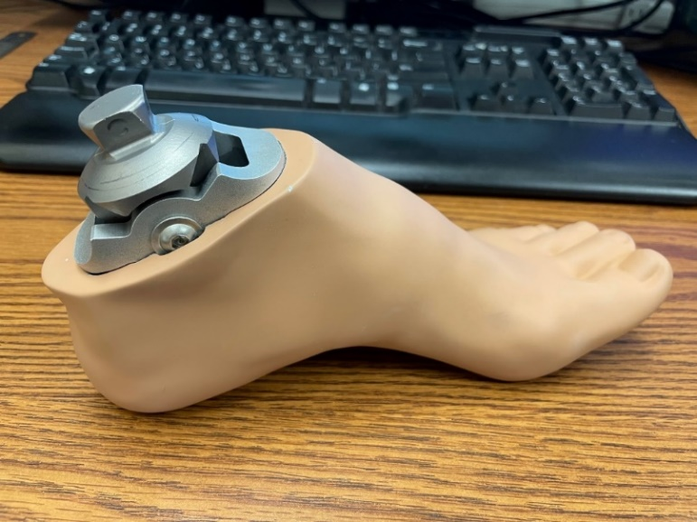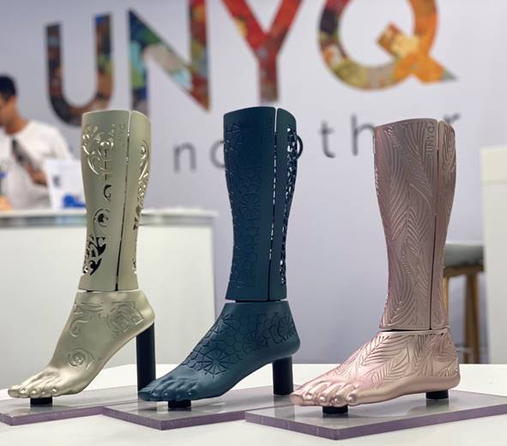
Images: New prosthetic foot system with a skin-tone finish on a foot shaped for a high-heeled shoe (left, courtesy of Minneapolis VA), and with three different colors, patterns, and heel heights (right, courtesy of UNYQ).
- COMPLETE: Validation of Patient-Reported Outcomes for Female Veterans with Upper-Limb Amputation (PI: Linda Resnick, Providence VA; October 1, 2018 – September 30, 2023). Refining outcome measures of upper limb prosthetic use to ensure test items and test scores adequately reflect issues important to women Veterans. This study producing modified versions of the TAPES psychosocial adjustment scale (a satisfaction measure responsive to the concerns of women), a modified PROMIS-UE short form with amputation-specific calibration, a physical function measure for prosthesis users (UEFS-P), a modified PEQ residual limb health scale, new measures of patient experience, new measures related to device affordability, and prosthesis acceptance. These measures were used to compare outcomes of men and women by amputation level and laterality and this work was presented at scientific conferences, through peer-reviewed publication and disseminated at a VA-DoD meeting.
- ONGOING: Artificial Digit Replacements for Women Veterans with Individual Digit Loss (PI: Richard Weir, Denver VA; October 1, 2018 – April 30, 2025). Redesigning and testing 3D-printed prosthetic fingers in sizes appropriate for women Veterans. Initial design study completed and fingers now available at https://www.pointdesignsllc.com/products/full-finger-prosthesis-mini. Follow-up study to complete take-home testing is ongoing.
Image: 3D printed women’s digits in size suitable for 5th percentile hands (courtesy of Weir Biomechatronics Development Laboratory)
- ONGOING: Brasthesis Prototype for Women Veterans with Upper Limb Amputations (PI: Sandra Winkler & Jeffrey Heckman, James A. Haley VA; April 1, 2022 – September 30, 2024). Will further develop and evaluate a women-specific transhumeral prosthetic suspension system based on integration with a sports bra.
- ONGOING: Improving Socket Fit in Female and Male Veterans with Transtibial and Transfemoral Amputation (PI: Alena Grabowski, Denver VA; April 1, 2022 – May 31, 2026). Will test effects of adjustable socket on biomechanical asymmetry, residual limb movement within the socket (socket pistoning), and comfort/satisfaction.

- ONGOING: Identifying the magnitude and impact of pelvic floor disorders in Veterans with lower limb amputation (PI: Sheila Clemens, Lexington, KY; December 1, 2022 – November 30, 2024). Will estimate the prevalence of pelvic floor dysfunction in a cohort of male and female Veterans with lower limb amputation and determine how it associates with low back pain, mobility, fall risk, and activity participation.

- ONGOING: Impact of Improving Footwear Options for Women Veterans with Amputations (PI: Andrew Hansen, Minneapolis, MN; April 1, 2023 – March 31, 2026). Follow-up study to determine the impact of improving footwear options for Women veterans with a modular prosthetic ankle-foot system on amputee-specific body image and participation.

- NEW: Do Transfemoral Prostheses with Powered Prosthetic Knee Flexion and Extension Improve Mobility? A Biomechanical Evaluation of the Ossur Power Knee (PI: Steve Gard, Chicago, IL April 1, 2024 – May 31, 2027). Perform a comparison of the new Ossur Power Knee to the Rheo XC on gait biomechanics, efficiency, and subjective perceptions on a range of daily activities. Gender-specific comparisons will be made across male and female subject groups to inform gender-specific device prescription.
For More Information on VA Women’s Health Research Network: WHRN@va.gov

